3
Distribution of Drugs

After entry into the systemic circulation, either by intravascular injection or by absorption from any of the various extravascular sites, the drug is subjected to a number of processes called as disposition processes. Disposition is defined as the processes that tend to lower the plasma concentration of drug. The two major drug disposition processes are –

- Distribution which involves reversible transfer of a drug between compartments.
- Elimination which causes irreversible loss of drug from the body. Elimination is further divided into two processes –
  - Biotransformation (metabolism)
  - Excretion.

The interrelationship between drug distribution, biotransformation and excretion and the drug in plasma is shown in Fig. 3.1.
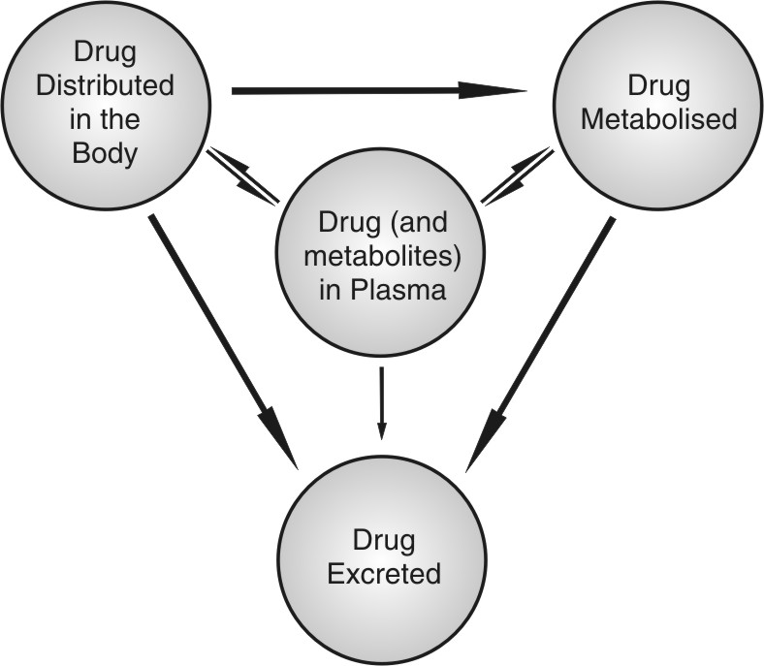
Fig. 3.1. Interrelationship between different processes of drug disposition
As stated above, distribution is defined as the reversible transfer of a drug between one compartment and another. Since the process is carried out by the circulation of blood, one of the compartments is always the blood or the plasma and the other represents extravascular fluids and other body tissues. In other words, distribution is reversible transfer of a drug between the blood and the extravascular fluids and tissues. Distribution is a passive process, for which, the driving force is concentration gradient between the blood and the extravascular tissues. The process occurs by diffusion of free drug only until equilibrium is achieved. As the pharmacological action of a drug depends upon its concentration at the site of action, distribution plays a significant role in the onset, intensity and sometimes duration of drug action.

Steps in Drug Distribution
Distribution of drug present in systemic circulation to extravascular tissues involves following steps (see figure 3.2) –
- Permeation of free or unbound drug present in the blood through the capillary wall (occurs rapidly) and entry into the interstitial/extracellular fluid (ECF).
- Permeation of drug present in the ECF through the membrane of tissue cells and into the intracellular fluid. This step is rate-limiting and depends upon two major factors –
  - Rate of perfusion to the extracellular tissue
  - Membrane permeability of the drug.
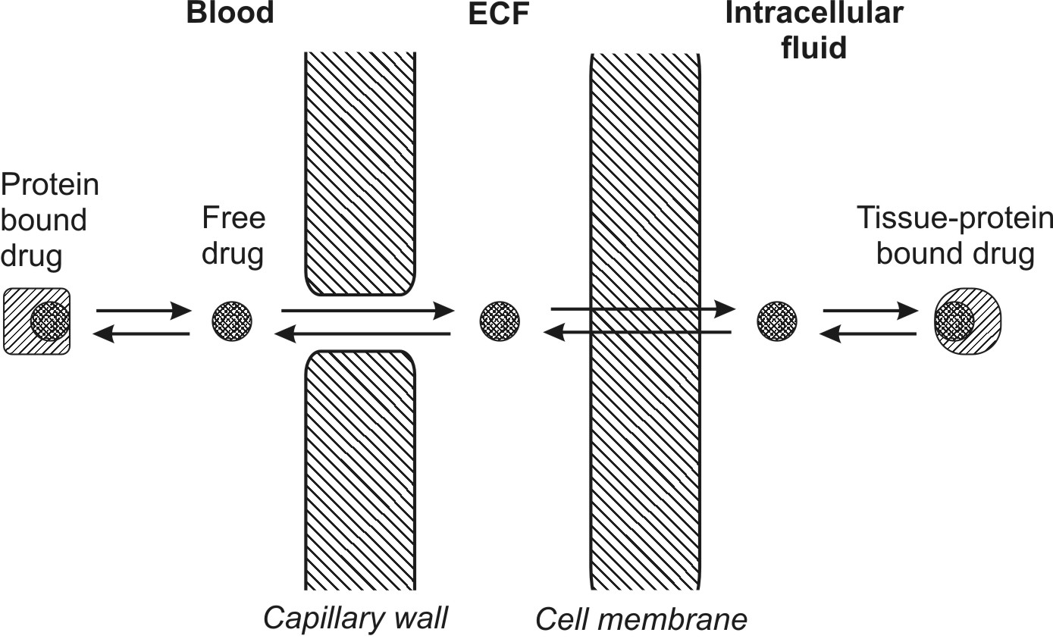
Fig. 3.2. Schematic of the steps involved in drug distribution

Factors Affecting Distribution of Drugs
Distribution of a drug is not uniform throughout the body because different tissues receive the drug from plasma at different rates and to different extents. Differences in drug distribution among the tissues essentially arise as result of a number of factors as enumerated below –
1. Tissue permeability of the drug:
- Physicochemical properties of the drug like molecular size, pKa and o/w partition coefficient
- Physiological barriers to diffusion of drugs
2. Organ/tissue size and perfusion rate
3. Binding of drugs to tissue components:
- Binding of drugs to blood components
- Binding of drugs to extravascular tissue proteins
4. Miscellaneous factors:
- Age
- Pregnancy
- Obesity
- Diet
- Disease states
- Drug interactions.

TISSUE PERMEABILITY OF DRUGS
Of the several factors listed above, the two major rate-determining steps in the distribution of drugs are:
- Rate of tissue permeation, and
- Rate of blood perfusion.

If the blood flow to the entire body tissues were rapid and uniform, differences in the degree of distribution between tissues will be indicative of differences in the tissue penetrability of the drug and the process will be tissue permeation rate-limited. Tissue permeability of a drug depends upon the physicochemical properties of the drug as well as the physiological barriers that restrict diffusion of drug into tissues.

Physicochemical Properties of the Drug
Important physicochemical properties of drug that influence its distribution are molecular size, degree of ionisation, partition coefficient and stereochemical nature.

Almost all drugs having molecular weight less than 500 to 600 Daltons easily cross the capillary membrane to diffuse into the extracellular interstitial fluids. However, penetration of drugs from the extracellular fluid into the cells is a function of molecular size, ionisation constant and lipophilicity of the drug. Only small, water-soluble molecules and ions of size below 50 Daltons enter the cell through aqueous filled channels whereas those of larger size are restricted unless a specialized transport system exists for them.

The degree of ionisation of a drug is an important determinant in its tissue penetrability. The pH of the blood and the extravascular fluid also play a role in the ionisation and diffusion of drugs into cells. A drug that remains unionised at these pH values can permeate the cells relatively more rapidly. Since the blood and the ECF pH normally remain constant at 7.4, they do not have much of an influence on drug diffusion unless altered in conditions such as systemic acidosis or alkalosis.

Most drugs are either weak acids or weak bases and their degree of ionisation at plasma or ECF pH depends upon their pKa. All drugs that ionise at plasma pH (i.e. polar, hydrophilic drugs), cannot penetrate the lipoidal cell membrane and tissue permeability is the rate-limiting step in the distribution of such drugs. Only unionised drugs which are generally lipophilic, rapidly cross the cell membrane. Among the drugs that have same o/w partition coefficient but differ in the extent of ionisation at blood pH, the one that ionises to a lesser extent will have greater penetrability than that which ionises to a larger extent; for example, pentobarbital and salicylic acid have almost the same Ko/w but the former is more unionised at blood pH and therefore distributes rapidly. The influence of drug pKa and Ko/w on distribution is illustrated by the example that thiopental, a nonpolar, lipophilic drug, largely unionised at plasma pH, readily diffuses into the brain whereas penicillins which are polar, water-soluble and ionised at plasma pH do not cross the blood-brain barrier (Fig. 3.3).

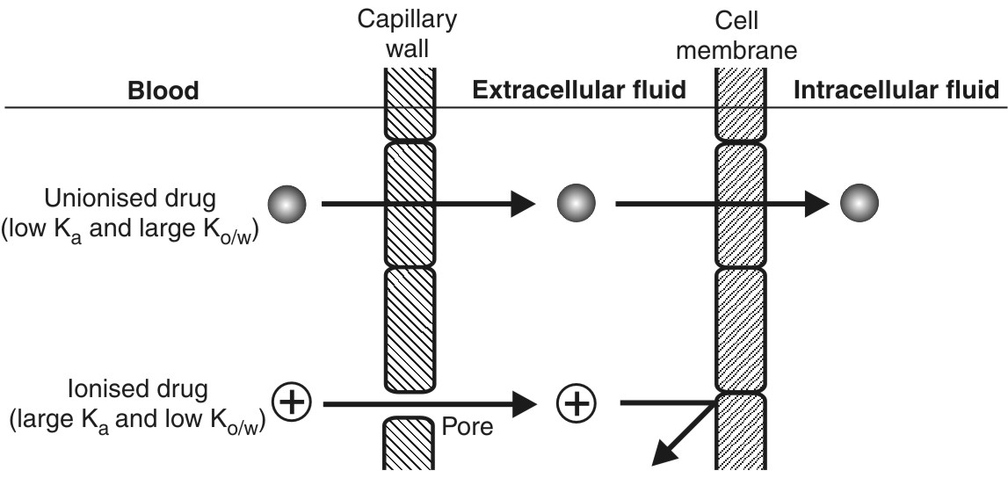
Fig. 3.3. Permeation of unionised and ionised drugs across the capillary and the cell membrane

Since the extent to which a drug exists in unionised form governs the distribution pattern, situations that result in alteration of blood pH affect such a pattern; for example, acidosis (metabolic or respiratory) results in decreased ionisation of acidic drugs and thus increased intracellular drug concentration and pharmacological action. Opposite is the influence of alkalosis. Sodium bicarbonate induced alkalosis is sometimes useful in the treatment of barbiturate (and other acidic drugs) poisoning to drive the drug out and prevent further entry into the CNS and promote their urinary excretion by favouring ionisation. Converse is true for basic drugs; acidosis favours extracellular whereas alkalosis, intracellular distribution.

In case of polar drugs where permeability is the rate-limiting step in the distribution, the driving force is the effective partition coefficient of drug. It is calculated by the following formula:
(3.1)
The extent to which the effective partition coefficient influences rapidity of drug distribution can be seen from the example given in Table 3.1.

Table 3.1.
Distribution of Acidic Drugs in CSF
Drug | Relative acidity | Effective Ko/w at pH 7.4 | Relative rate of distribution
Thiopental | Weaker acid | 2.0 | 80
Salicylic acid | Stronger acid | 0.0005 | 1
Thus, thiopental distributes in CSF at a rate 80 times faster than salicylic acid.

Stereochemical nature of drug will also influence the distribution characteristics especially when it has a tendency to interact with macromolecules like proteins. Tissue localisation of certain drugs may be an indication of stereoselectivity in drug distribution.

Physiological Barriers to Distribution of Drugs
A membrane (or a barrier) with special structural features can be a permeability restriction to distribution of drugs to some tissues. Some of the important simple and specialized physiological barriers are:
  - Simple capillary endothelial barrier
  - Simple cell membrane barrier
  - Blood-brain barrier
  - Blood-CSF barrier
  - Blood- placental barrier
  - Blood-testis barrier.

The Simple Capillary Endothelial Barrier: The membrane of capillaries that supply blood to most tissues is, practically speaking, not a barrier to moieties which we call drugs. Thus, all drugs, ionised or unionised, with a molecular size less than 600 Daltons, diffuse through the capillary endothelium and into the interstitial fluid. Only drugs bound to the blood components are restricted because of the large molecular size of the complex.

The Simple Cell Membrane Barrier: Once a drug diffuses from the capillary wall into the extracellular fluid, its further entry into cells of most tissues is limited by its permeability through the membrane that lines such cells. Such a simple cell membrane is similar to the lipoidal barrier in the GI absorption of drugs (discussed in chapter 2).

The physicochemical properties that influence permeation of drugs across such a barrier are summarized in Fig. 3.4.
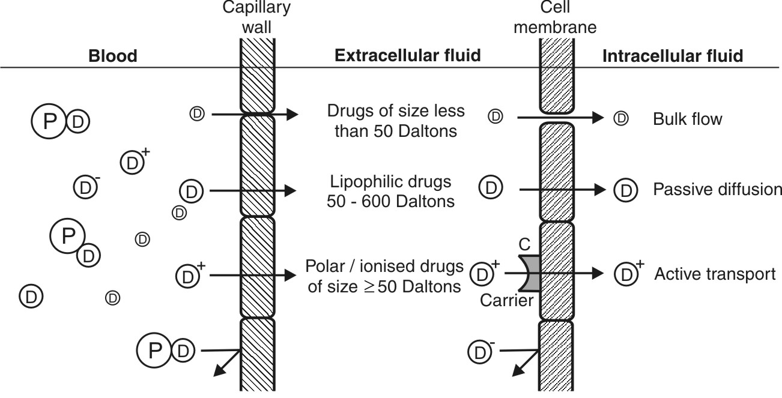
Fig. 3.4. Plasma membrane barrier and drug diffusion across it
Blood-Brain Barrier (BBB): Unlike the capillaries found in other parts of the body, the capillaries in the brain are highly specialized and much less permeable to water-soluble drugs. The brain capillaries consist of endothelial cells which are joined to one another by continuous tight intercellular junctions comprising what is called as the blood-brain barrier (Fig. 3.5). Moreover, the presence of special cells called as pericytes and astrocytes, which are the elements of the supporting tissue found at the base of endothelial membrane, form a solid envelope around the brain capillaries. As a result, the intercellular (paracellular) passage is blocked and for a drug to gain access from the capillary circulation into the brain, it has to pass through the cells (transcellular) rather than between them. (However, there are specific sites in the brain where the BBB does not exist, namely, the trigger area and the median hypothalamic eminence. Moreover, drugs administered intranasally may diffuse directly into the CNS because of the continuity between submucosal areas of the nose and the subarachnoid space of the olfactory lobe). There is also virtual absence of pinocytosis in brain.

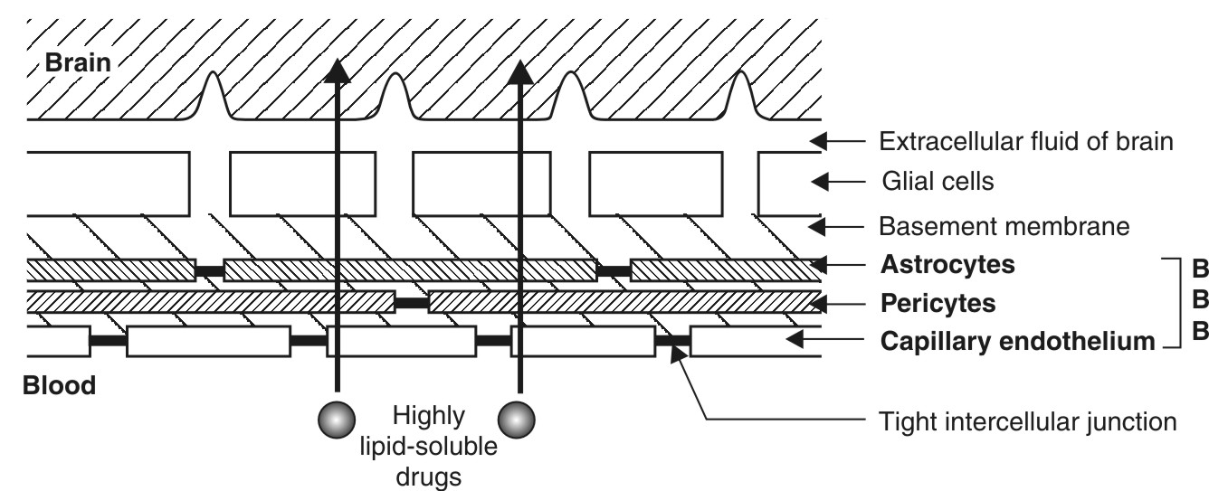
Fig. 3.5. Blood-brain barrier
A solute may thus gain access to brain via only one of two pathways:
- Passive diffusion through the lipoidal barrier – which is restricted to small molecules (with a molecular weight less than a threshold of approximately 700 Daltons) having high o/w partition coefficient.
- Active transport of essential nutrients such as sugars and amino acids. Thus, structurally similar foreign molecules can also penetrate the BBB by the same mechanism.
The effective partition coefficient of thiopental, a highly lipid soluble drug is 50 times that of pentobarbital and crosses the BBB much more rapidly. Most antibiotics such as penicillin which are polar, water-soluble and ionised at plasma pH, do not cross the BBB under normal circumstances.
The selective permeability of lipid soluble moieties through the BBB makes appropriate choice of a drug to treat CNS disorders an essential part of therapy; for example, Parkinsonism, a disease characterized by depletion of dopamine in the brain, cannot be treated by administration of dopamine as it does not cross the BBB. Hence, levodopa, which can penetrate the CNS where it is metabolised to dopamine, is used in its treatment. Targeting of polar drugs to brain in certain conditions such as tumour had always been a problem. Three different approaches have been utilized successfully to promote crossing the BBB by drugs:
- Use of permeation enhancers such as dimethyl sulphoxide (DMSO).
- Osmotic disruption of the BBB by infusing internal carotid artery with mannitol.
- Use of dihydropyridine redox system as drug carriers to the brain.
In the latter case, the lipid soluble dihydropyridine is linked as a carrier to the polar drug to form a prodrug that readily crosses the BBB. In the brain, the CNS enzymes oxidize the dihydropyridine moiety to the polar pyridinium ion form that cannot diffuse back out of the brain. As a result, the drug gets trapped in the CNS. Such a redox system has been used to deliver steroidal drugs to the brain.
Blood-Cerebrospinal Fluid Barrier: The cerebrospinal fluid (CSF) is formed mainly by the choroid plexus of the lateral, third and fourth ventricles and is similar in composition to the ECF of brain. The capillary endothelium that lines the choroid plexus have open junctions or gaps and drugs can flow freely into the extracellular space between the capillary wall and the choroidal cells. However, the choroidal cells are joined to each other by tight junctions forming the blood-CSF barrier which has permeability characteristics similar to that of the BBB (Fig. 3.6).
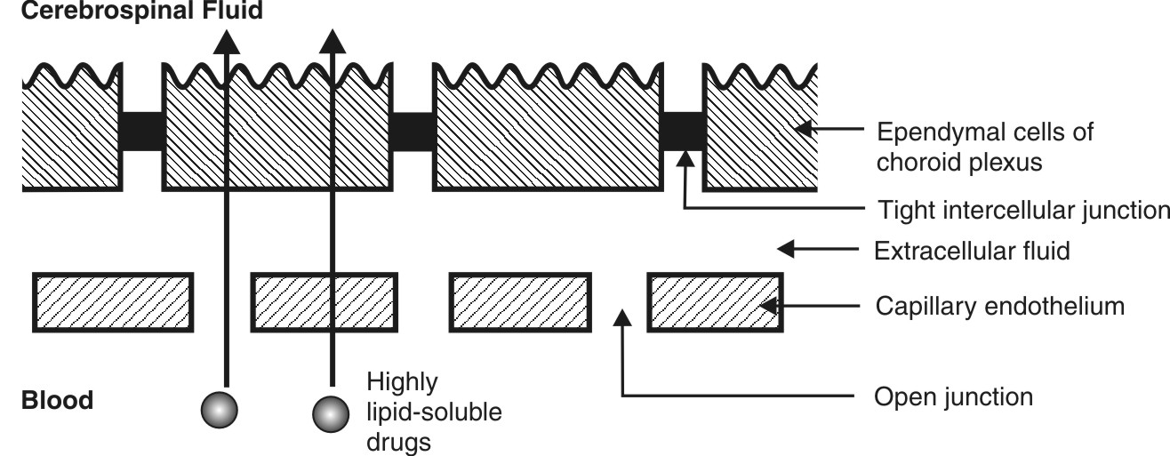
Fig. 3.6. The blood-CSF barrier
As in the case of BBB, only highly lipid soluble drugs can cross the blood-CSF barrier with relative ease whereas moderately lipid soluble and partially ionised drugs permeate slowly. A drug that enters the CSF slowly cannot achieve a high concentration as the bulk flow of CSF continuously removes the drug. For any given drug, its concentration in the brain will always be higher than in the CSF.
Although the mechanisms for diffusion of drugs into the CNS and CSF are similar, the degree of uptake may vary significantly. In some cases, CSF drug concentration may be higher than its cerebral concentration e.g. sulphamethoxazole and trimethoprim, and vice versa in other cases, e.g. certain β-blockers.
Blood-Placental Barrier: The maternal and the foetal blood vessels are separated by a number of tissue layers made of foetal trophoblast basement membrane and the endothelium which together constitute the placental barrier. The flow of blood in the maternal and the foetal blood vessels is shown in Fig. 3.7.
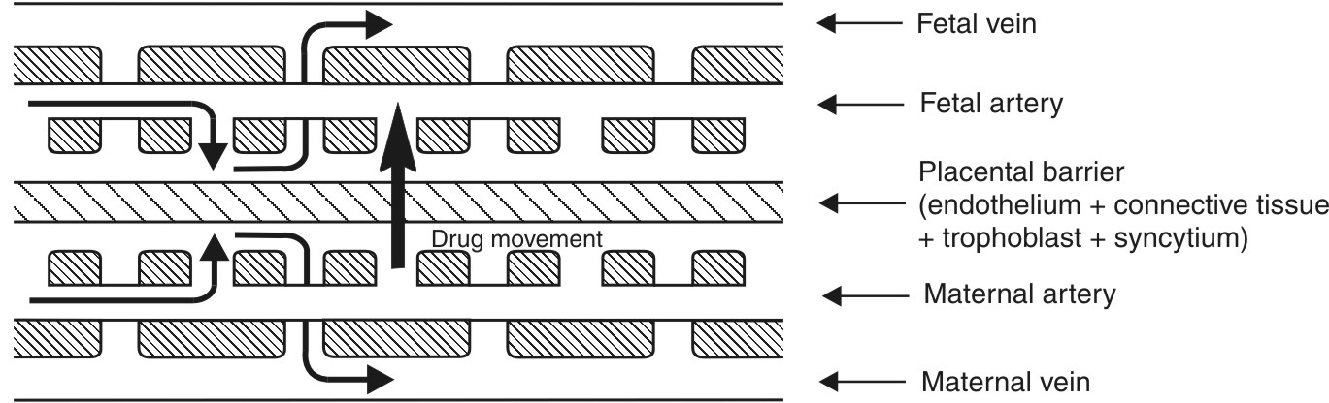
Fig. 3.7. Placental barrier and blood flow across it
The human placental barrier has a mean thickness of 25 microns in early pregnancy that reduces to 2 microns at full term which however does not reduce its effectiveness. Many drugs having molecular weight less than 1000 Daltons and moderate to high lipid solubility e.g. ethanol, sulphonamides, barbiturates, gaseous anaesthetics, steroids, narcotic analgesics, anticonvulsants and some antibiotics, cross the barrier by simple diffusion quite rapidly. This shows that the placental barrier is not as effective a barrier as BBB. Nutrients essential for the foetal growth are transported by carrier-mediated processes. Immunoglobulins are transported by endocytosis.

An agent that causes toxic effects on foetus is called as teratogen. Teratogenecity is defined as foetal abnormalities caused by administration of drugs during pregnancy.
Drugs can affect the foetus at 3 stages as shown in table 3.2.

TABLE 3.2.
Stages during which teratogens show foetal abnormalities
Period | Significance | Harmful effects
First 2 weeks | Fertilization and implantation stage | Miscarriage
2 – 8 weeks | Period of organogenesis | Cleft palate, optic atrophy, mental retardation, neural tube defects, etc.
8 weeks onwards | Growth and development | Development and functional abnormalities
It is always better to restrict all drugs during pregnancy because of the uncertainty of their hazardous effects.
Blood-Testis Barrier: This barrier is located not at the capillary endothelium level but at sertoli-sertoli cell junction. It is the tight junctions between the neighbouring sertoli cells that act as the blood-testis barrier. This barrier restricts the passage of drugs to spermatocytes and spermatids.
ORGAN/TISSUE SIZE and PERFUSION rate
As discussed until now, distribution is permeability rate-limited in the following cases:
- When the drug under consideration is ionic, polar or water-soluble.
- Where the highly selective physiologic barriers restrict the diffusion of such drugs to the inside of the cell.
In contrast, distribution will be perfusion rate-limited when:
- The drug is highly lipophilic.
- The membrane across which the drug is supposed to diffuse is highly permeable such as those of the capillaries and the muscles.
Whereas only highly lipophilic drugs such as thiopental can cross the most selective of the barriers like the BBB, highly permeable capillary wall permits passage of almost all drugs (except those bound to plasma proteins). In both circumstances, the rate-limiting step is the rate of blood flow or perfusion to the tissue. Greater the blood flow, faster is the distribution.
Perfusion rate is defined as the volume of blood that flows per unit time per unit volume of the tissue. It is expressed in ml/min/ml of the tissue. The perfusion rate of various tissues is given in Table 3.3.
In Table 3.3, the various tissues are listed in decreasing order of their perfusion rate which indicates the rapidity with which the drug will be distributed to the tissues. Highly perfused tissues such as lungs, kidneys, adrenal, liver, heart and brain are rapidly equilibrated with lipid soluble drugs.
Table 3.3.
Relative Volume of Different Organs, Blood Flow and Perfusion Rate under Basal Conditions Assuming the Total Body Volume to be 70 litres
Organ/tissue | % of Body Volume | Blood Flow (ml/min) | % of Cardiac Output | Perfusion Rate (ml/min/ml)
I. Highly Perfused
1. Lungs | 0.7 | 5000 | 100.0 | 10.2
2. Kidneys | 0.4 | 1250 | 25.0 | 4.5
3. Adrenals | 0.03 | 25 | 0.5 | 1.2
4. Liver | 2.3 | 1350 | 27.0 | 0.8
5. Heart | 0.5 | 200 | 4.0 | 0.6
6. Brain | 2.0 | 700 | 14.0 | 0.5
II. Moderately Perfused
7. Muscles | 42.0 | 1000 | 20.0 | 0.034
8. Skin | 15.0 | 350 | 7.0 | 0.033
III. Poorly Perfused
9.Fat (adipose) | 10.0 | 200 | 4.0 | 0.03
10.Bone (skeleton) | 16.0 | 250 | 5.0 | 0.02
If Kt/b is the tissue/blood partition coefficient of drug then the first-order distribution rate constant, Kt, is given by following equation:
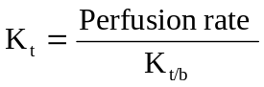 | (3.2)
The tissue distribution half-life is given by equation:
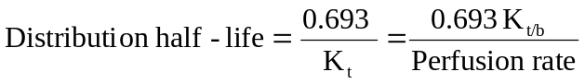 | (3.3)
The extent to which a drug is distributed in a particular tissue or organ depends upon the size of the tissue (i.e. tissue volume) and the tissue/blood partition coefficient of the drug. Consider the classic example of thiopental. This lipophilic drug has a high tissue/blood partition coefficient towards the brain and still higher for adipose tissue. Since the brain (site of action) is a highly perfused organ, following i.v. injection, thiopental readily diffuses into the brain showing a rapid onset of action. Adipose tissue being poorly perfused, takes longer to get distributed with the same drug. But as the concentration of thiopental in the adipose proceeds towards equilibrium, the drug rapidly diffuses out of the brain and localizes in the adipose tissue whose volume is more than 5 times that of brain and has greater affinity for the drug. The result is rapid termination of action of thiopental due to such a tissue redistribution.
BINDING OF DRUGS TO TISSUE COMPONENTS
A drug in the body can bind to several components such as the plasma proteins, blood cells and haemoglobin (i.e. blood components) and extravascular proteins and other tissues. This topic is dealt comprehensively in chapter 4 on Protein Binding of Drugs.
MISCELLANEOUS FACTORS AFFECTING DRUG DISTRIBUTION
Age
Differences in distribution pattern of a drug in different age groups are mainly due to differences in—
- Total body water (both intracellular and extracellular) — is much greater in infants
- Fat content — is also higher in infants and elderly
- Skeletal muscles — are lesser in infants and in elderly
- Organ composition — the BBB is poorly developed in infants, the myelin content is low and cerebral blood flow is high, hence greater penetration of drugs in the brain
- Plasma protein content — low albumin content in both infants and in elderly
Pregnancy
During pregnancy, the growth of uterus, placenta and foetus increases the volume available for distribution of drugs. The foetus represents a separate compartment in which a drug can distribute. The plasma and the ECF volume also increase but there is a fall in albumin content.
Obesity
In obese persons, the high adipose tissue content can take up a large fraction of lipophilic drugs despite the fact that perfusion through it is low. The high fatty acid levels in obese persons alter the binding characteristics of acidic drugs.
Diet
A diet high in fats will increase the free fatty acid levels in circulation thereby affecting binding of acidic drugs such as NSAIDs to albumin.
Disease States
A number of mechanisms may be involved in the alteration of drug distribution characteristics in disease states:
  - Altered albumin and other drug-binding protein concentration.
  - Altered or reduced perfusion to organs or tissues.
  - Altered tissue pH.
An interesting example of altered permeability of the physiologic barriers is that of BBB. In meningitis and encephalitis, the BBB becomes more permeable and thus polar antibiotics such as penicillin G and ampicillin which do not normally cross it, gain access to the brain. In a patient suffering from CCF, the perfusion rate to the entire body decreases affecting distribution of all drugs.
Drug Interactions
Drug interactions that affect distribution are mainly due to differences in plasma protein or tissue binding of drugs. This topic is discussed under the same heading in chapter 4.
VOLUME OF DISTRIBUTION
A drug in circulation distributes to various organs and tissues. When the process of distribution is complete (at distribution equilibrium), different organs and tissues contain varying concentrations of drug which can be determined by the volume of tissues in which the drug is present. Since different tissues have different concentrations of drug, the volume of distribution cannot have a true physiologic meaning. However, there exists a constant relationship between the concentration of drug in plasma, C, and the amount of drug in the body, X.
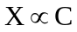
or, 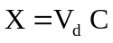 | (3.4)

where Vd = proportionality constant having the unit of volume and popularly called as apparent volume of distribution. It is defined as the hypothetical volume of body fluid into which a drug is dissolved or distributed. It is called as apparent volume because all parts of the body equilibrated with the drug do not have equal concentration.
Thus, from equation 3.4, Vd is given by the ratio:
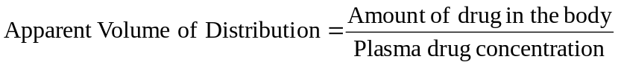
or, 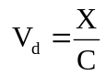 | (3.5)

The apparent volume of distribution bears no direct relationship with the real volume of distribution.
The real volume of distribution has direct physiologic meaning and is related to the body water. The body water is made up of 3 distinct compartments as shown in the Table 3.4.

Table 3.4.
Fluid Compartments of a 70 Kg Adult
Body Fluid | Volume (litres) | % of Body Weight | % of TBW
1. Vascular fluid/blood (Plasma) | 6  (3) | 9  (4.5) | 15  (7.5)
2.Extracellular fluid (excluding plasma) | 12 | 17 | 28
3. Intracellular fluid (excluding blood cells) | 24 | 34 | 57
Total Body Water (TBW) | 42 | 60 | 100
The volume of each of these real physiologic compartments can be determined by use of specific tracers or markers (Table 3.5). The plasma volume can be determined by use of substances of high molecular weight or substances that are totally bound to plasma albumin, for e.g. high molecular weight dyes such as Evans blue, indocyanine green and I-131 albumin. When given i.v., these remain confined to the plasma. The total blood volume can also be determined if the haematocrit is known. The extracellular fluid (ECF) volume can be determined by substances that easily penetrates the capillary membrane and rapidly distribute throughout the ECF but do not cross the cell membranes, for e.g. the Na+, Cl-, Br–, SCN– and SO42– ions and inulin, mannitol and raffinose. However, none of these substances are completely kept out of the cells. The ECF volume, excluding plasma is approximately 15 litres. The total body water (TBW) volume can be determined by use of substances that distribute equally in all water compartments of the body (both intra- and extracellular), for e.g. heavy water (D2O), tritiated water (HTO) and lipid soluble substances such as antipyrine. The intracellular fluid volume is determined as the difference between the TBW and ECF volume. The intracellular fluid volume including those of blood cells is approximately 27 litres.

Table 3.5.
Markers Used to Measure the Volume of Real Physiological Compartments
Physiological Fluid Compartment | Markers Used | Approximate Volume (litres)
Plasma | Evans blue, indocyanine green, I-131, albumin | 3
Erythrocytes | Cr-51 | 2
Extracellular fluid | Non-metabolisable saccharides like raffinose, inulin, mannitol and radioisotopes of selected ions: Na+, Cl–, Br–, SO42– | 15
Total body water | D2O, HTO, antipyrine | 42
Since the tracers are not bound or negligibly bound to plasma or tissue proteins, their apparent volume of distribution is same as their true volume of distribution. The situation is different with most drugs which bind to plasma proteins or extravascular tissues or both. Certain generalizations can be made regarding the apparent volume of distribution of such drugs:
  - Drugs which bind selectively to plasma proteins or other blood components, e.g. warfarin (i.e. those that are less bound to extravascular tissues), have apparent volume of distribution smaller than their true volume of distribution. The Vd of such drugs lies between blood volume and TBW volume (i.e. between 6 to 42 litres); for example, warfarin has a Vd of about 10 litres.
  - Drugs which bind selectively to extravascular tissues, e.g. chloroquine (i.e. those that are less bound to blood components), have apparent volume of distribution larger than their real volume of distribution. The Vd of such drugs is always greater than 42 litres or TBW volume; for example, chloroquine has a Vd of approximately 15,000 litres. Such drugs leave the body slowly and are generally more toxic than drugs that do not distribute deeply into body tissues.
Thus, factors that produce an alteration in binding of drug to blood components, result in an increase in Vd and those that influence drug binding to extravascular components result in a decrease in Vd. Other factors that may influence Vd are changes in tissue perfusion and permeability, changes in the physicochemical characteristics of the drug e.g. ionisation, changes in the body weight and age and several disease states.
Apparent volume of distribution is expressed in litres and sometimes in litres/Kg body weight. The Vd of various drugs ranges from as low as 3 litres (plasma volume) to as high as 40,000 litres (much above the total body size). Many drugs have Vd greater than 30 litres. The Vd is a characteristic of each drug under normal conditions and is altered under conditions that affect distribution pattern of the drug.
QUESTIONS
- Define — (a) disposition, and (b) distribution of drugs. What is the major mechanism for distribution of drugs and what is its driving force?
- Unless distribution occurs, the drug may not elicit pharmacological response. Explain.
- Why is distribution of a drug not uniform throughout the body? List the factors influencing drug distribution.
- What are the two major rate-limiting steps in the distribution of drugs? Under what circumstances are they applicable?
- Which physicochemical properties of the drug limit its distribution?
- Phenobarbital and salicylic acid have almost the same Ko/w but the former shows extensive distribution. Why?
- What is the influence of change in plasma pH on distribution pattern of a drug? Based on pKa values, which drugs are most affected and which will be least affected by a change in plasma pH?
- What parameter is considered to be the driving force for distribution of polar drugs?
- Why cannot the capillary endothelium be considered a barrier to distribution of unbound drugs? What would be the consequence or fate of drugs had it been a selective barrier?
- Name the specialized barriers to distribution of drugs.
- Describe the anatomy and physiology of blood brain barrier. What characteristics of a drug are necessary to penetrate such a barrier?
- How do nutrients which are generally polar, make their way into the brain?
- Polar drugs such as penicillin normally do not cross BBB but do so in meningitis. Explain.
- Name the three approaches by which a polar drug can be targeted to brain.
- Drugs that penetrate the CNS slowly may never achieve adequate therapeutic brain concentrations. Why?
- Why is the placental barrier not as effective as BBB?
- In which periods drugs are particularly harmful to foetus in pregnant women?
- How are body tissues classified on the basis of perfusion rate?
- Thiopental is a highly lipophilic, centrally acting drug. By which route should it be administered for rapid onset of action? Why? What is the reason for its rapid termination of action?
- Which are the factors responsible for the differences in drug distribution in persons of different age groups?
- What are the various mechanisms involved in the alteration of drug distribution characteristics in disease states?
- Define apparent volume of distribution. Why cannot the volume of distribution of a drug have a true physiologic meaning?
- What are the various physiologic fluid compartments of the body? What are their volumes and how are they estimated?
- The tracers used to determine the volume of body fluids have Vd same as their true volume. Why?
- How are the binding characteristics of a drug related to its Vd? Explain why some drugs have Vd value larger than TBW volume?
- It is better to express Vd in litres/Kg body weight. Why?
- Can a drug have two or more Vd values? Explain why?
- The tissue/blood partition coefficient values of a drug and tissue perfusion rates are given in table below:
Tissues Kt/b Perfusion Rate Kt Distribution t½
Liver 1 0.8
Brain 4 0.5
Muscle 8 0.035
Fat 40 0.03
Determine the rate constants for distribution and distribution half-lives.
Answer: Kt values (per minute): liver - 0.8, brain - 0.125, muscle - 0.0044 and fat - 0.00075; distribution t½ values (in minutes): liver - 0.86, brain - 5.54, muscle - 158.4 and fat - 924.
29. The Vd of fluoxetine is 3000 litres. Calculate —
a. The amount of drug in the body when the plasma concentration is 1 ng/ml.
Answer: 3 mg.
b. The plasma concentration when the amount of drug in the body is 2 mg.
Answer: 0.67 ng/ml.
c. The % of drug that is present in plasma.
Answer: 0.1%.
30. The Vd of three drugs—A, B and C are 12, 42 and 400 litres respectively.
a. Determine the % drug present outside plasma.
Answer: drug A - 75%, drug B - 93% and drug C - 99.3%.
b. Which drug is most extensively distributed in e.v. tissues?
c. If binding of drugs is negligible, which of the three can be used as markers and for which fluid compartments?

